Reclaiming your NT auctions

Are you frustrated by opponents who stick their noses into the auction when your partner opens 1 No Trump? If you haven’t learned ways to combat this interference, you’re missing out on some great opportunities; and if you attempt to combat this interference without discussing responder’s options with your partner, you are stepping into a minefield. So put this topic on your “Must Discuss” list with any new partner.

Today, I want to present a method for coping with ‘nosy’ opponents. There are many methods to choose from, including lebensohl. You should choose one that feels right for you, based on the tradeoffs involved, and discuss it, at length, with your partner.

Here is a list of tradeoff factors, in no particular order:
- Are our bids easy to remember (minimizing disaster potential) and effective?
- Can you penalize ‘nosy’ opponents?
- Can responder bid Stayman?
- Can responder still transfer opener?
- Can responder show or deny stopper(s) in the opponent’s suit(s)?
- Can responder show a suit of her own?
- Can responder distinguish between invitational bids and forcing bids?

I submit that all tradeoff factors can be handled with the lebensohl method, except for “easy to remember”. So if we eliminate that, what methods are available?

We’ll discuss “stolen bids”, and I’ll suggest that you eliminate most of them. So if we reject most of your stolen bid arsenal, what do we replace it with?
- - -

Suppose you’re the dealer, and you’ve passed, LHO has passed, and partner opens 1 No Trump. Before you can proudly announce “fifteen to seventeen”, RHO drops a 2 Heart card on the table, and LHO says, “ALERT”. Your elation over partner’s strong 1NT bid (I’m assuming strong 15-17, or 16-18 hcp 1NT opening bids) has become frustration because now you feel you have no option except passing.

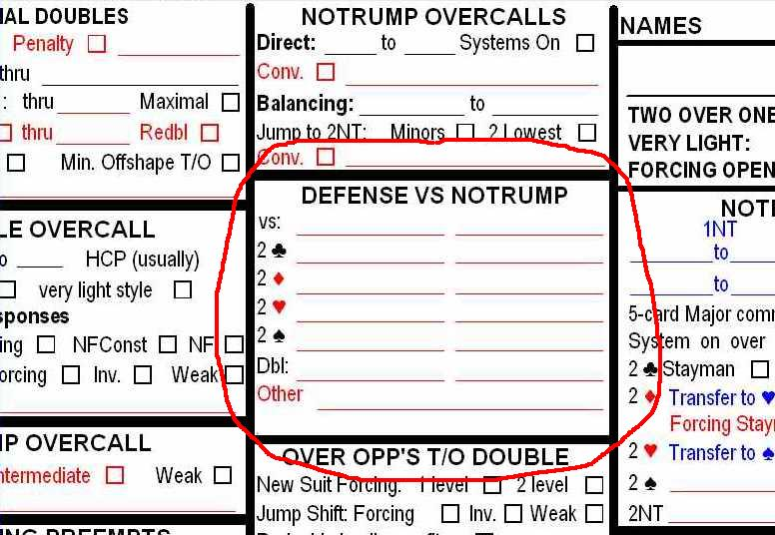
If you were considering a bid, then before doing anything else, you ought to ask LHO what the alerted bid means. [Do you know where to look on the convention card for information describing these interfering bids?] The best policy for asking about opponents alerted bids is to ask only when you were thinking about bidding, and knowing the meaning of the alert will be important for your potential bidding decision. If you were going to pass before the alerted bid was made, then don’t ask. Remember, when you ask the opponents about their bids, you are giving them a chance to clarify their understanding of their bids to each other – a sometimes necessary evil.

The easiest method to remember and to use is loosely called “stolen bid double”. A double here advises opener that the opponent’s overcall “stole” the bid that the responder wanted to make.
partner opp you
1NT 2♥ dbl Here responder doubles to say that responder wanted to bid 2♥ (transfer to ♠).

The stolen bid is effective here only when you have 5 or more spades. What if you have only 4 spades and 7-9 hcp? You must pass. The opponents have frustrated you again.

So although “stolen bid doubles” are easy to understand, they have serious flaws. First, playing stolen bids is an open invitation to your opponents to have a field day with obtrusive interference at the two-level and deprives you of the ability to penalize them. Second, it is not always possible to make a stolen bid double, especially when the overcall is artificial, as in the Landy and Cappelletti defenses to no trump openers. In Cappelletti, 2♦ shows the majors, so you can hardly want your partner to transfer into hearts with a stack of hearts behind her. The same is true of a Landy 2♣ bid showing the majors. Now Stayman doesn’t make a lot of sense. So now what?

I suggest that you limit the “stolen bid double” to apply only after an opponent’s overcall of 2♣. After a 2♣ overcall, a double by responder is Stayman. When the opponents double, all of responder’s bids mean the same as they did without the double. You ignore the double. This costs hardly anything. Transfers and an invitational bid of 2NT by responder mean the same as those bids would have meant without the double.

partner opp you
1NT 2♣ dbl Here responder doubles to say that responder wanted to bid 2♣ (Stayman).
1NT dbl 2♣ Here responder ignores the double and bids 2♣ (Stayman).
1NT dbl 2♦ Here responder ignores the double and bids 2♦ (transfer to ♥)
1NT dbl 2♥ Here responder ignores the double and bids 2♥ (transfer to ♠)
1NT dbl 2♠ Here responder ignores the double and bids 2♠ (relay to ♣, or other meaning)

How do you handle higher suit overcalls? Let’s return to auction with a 2 heart overcall. How do you bid with these hands when the auction has begun P – P -- 1NT - 2♥ - ?
- ♠xx ♥xx ♦Jxx ♣KJxxxx (you’d like clubs to be trumps)
- ♠Ax ♥xx ♦Qxx ♣KQxxxx (with 11 hcp, you’d like to be in game, but which one?)
- ♠xx ♥Qx ♦KJxxxx ♣xxx (you’d like diamonds to be trumps)

Here are the lebensohl responses for responder:
1. Pass with no 5-card suit and less than 6 points.
2. A double is negative (takeout) at the two or three level (7 or more hcp).
3. A new suit bid at the two level shows a length of five or more, is natural and to play.
4. A new suit bid at the three level shows a length of five or more, is natural and forcing.
5. 2NT is lebensohl and is a relay to 3♣. [This bid must be alerted by partner!]

Item 5 above is usually referred to as the lebensohl convention, and it is used to distinguish between good and bad hands where you want to play in a suit below the overcaller’s suit.

- - -

With hands 1 and 3, you’d like to play 3 of your minor; otherwise, your hand is worthless. With hand 2, you’d like to suggest to partner that you have game-going values (11 hcp!), and a long club suit. If pard has a heart stopper, 3NT might be a good contract. How do you distinguish between these 3 hands? With the first and third, you first bid 2NT (ALERT! by partner). Partner will say that your bid is a “relay to 3♣” if partner is asked for a description. At partner’s turn, she will bid 3♣, which you will pass, or correct to 3♦. Partner is expected to pass your 3♦ call.

To review: the auction should go as shown with each hand:
♠xx ♥xx ♦Jxx ♣KJxxxx 1NT - 2♥ - 2NT! – Pass – 3♣ – Pass – Pass – Pass
♠Ax ♥xx ♦Qxx ♣KQxxxx 1NT - 2♥ - 3♣ - Pass - ???NOT PASS
♠xx ♥Qx ♦KJxxxx ♣xxx 1NT - 2♥ - 2NT! – Pass – 3♣ – Pass – 3♦ – Pass – Pass - Pass

- - -

Now, what about the double call, which I suggest you do not use globally as a “stolen bid”? There are two camps: double as penalty vs. double as takeout (negative). I believe there are far more hands where the takeout (negative) double applies than when a penalty double applies. I can’t remember ever having a penalty double of an artificial overcall of 1NT pay off. Ever. The opponents always bid on to find their fit. If you double their artificial bid, partner won’t know whether your double is based on length in their suit or strength in the suit, so your double doesn’t help partner very much.

Here are some hands where a negative double would be appropriate when the auction has been
1NT - 2♠ - double (negative)
- ♠xx ♥Kxxx ♦xxx ♣Axxx (you’ll pass pard’s bid; if pard passes for penalty, that’s ok.)
- ♠xxx ♥AJxx ♦Kxx ♣Txx ( “ )
- ♠xx ♥KTxx ♦xxx ♣KQxx ( “ )
- ♠xx ♥Kxxx ♦AJx ♣Kxxx (you’ll want to investigate game )
- ♠xx ♥Kxx ♦AJxx ♣xxxx (in a pinch 3 hearts will do -- just don’t pass with 8 hcp!)
- ♠Qxx ♥Qx ♦Jxxx ♣Qxxx (JUST KIDDING. DON’T DOUBLE WITH THESE 7 hcp!)

Keep in mind, you haven’t given up penalty doubles – partner can always pass your negative double and convert it to penalty, since partner knows you have 7-8 hcp. You can count on much squirming to occur when that happens.

References
The Lebensohl Convention Complete in Contract Bridge by Ron Andersen, Devyn Press, 1987.

Stolen Bids after opponents overcall partner's 1NT opening. http://www.bridgeaholics.com/bidding/gadgets/stolenbids.html

A summary of “stolen bids” by Mel Colchamiro. These articles appeared in the ACBL Bridge Bulletin, Dec 2008 – Apr 2009, and all 4 articles are combined in this web page. http://www.lajollabridge.com/LJUnit/Education/AgainstStolenBids.pdf

“Handling Interference over 1NT”, ACBL Bridge Bulletin March 2010, unattributed. Also available on-line, after logging in to http://web.acbl.org

